Practice 6.2: Graphing Cube Root and Cubic Functions
Algebra 2
Graph and provide requested information. Round to 2 decimal places when necessary.

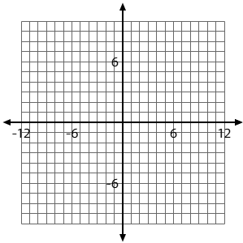
1) $f(x)=2\sqrt[3]{-x-2}$
Characteristics
Transformations:

x-intercept:
y-intercept:


2) $f(x)=3\sqrt[3]{x+2}-1$
Characteristics
Transformations:

x-intercept:
y-intercept:

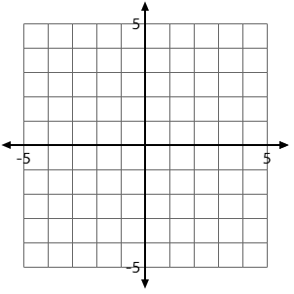
3) $f(x)=-\frac{1}{2}(x+1)^{3}+2$
Characteristics
Transformations:

x-intercept:
y-intercept:

4) $f(x)=2(3x-9)^{1/3}+2$
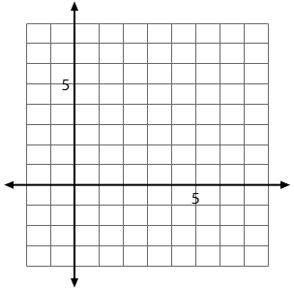

Characteristics
Transformations:

x-intercept:
y-intercept:

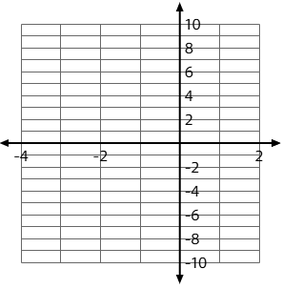
5) $f(x)=-(2x+4)^{3}-1$

Characteristics
Transformations:

x-intercept:
y-intercept:

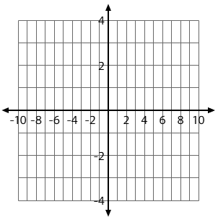
6)$f(x)=-\frac{1}{4}(-x+2)^{1/3}$
Characteristics
Transformations:

x-intercept:
y-intercept:

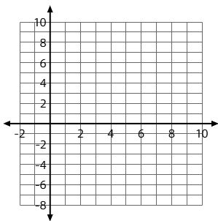
7) $f(x)=-(-\frac{1}{2}x+3)^{3}+2$
Characteristics
Transformations:

x-intercept:
y-intercept:

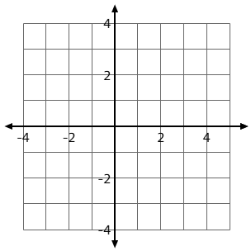
8)$f(x)=-\frac{1}{4}(-x+2)^{3}$
Characteristics
Transformations:

x-intercept:
y-intercept:

